

Practices for Secure Software Report

Table of Contents
Document Revision History 3
Client 3
Instructions 3
Developer 4
1. Algorithm Cipher 4
2. Certificate Generation 4
3. Deploy Cipher 4
4. Secure Communications 4
5. Secondary Testing 4
6. Functional Testing 4
7. Summary 4
8. Industry Standard Best Practices 4

Document Revision History

Version | Date | Author | Comments
1.0 | 2/16/26 | Alyssa Boyce

Client



Instructions

Submit this completed practices for secure software report. Replace the bracketed text with the relevant information. You must document your process for writing secure communications and refactoring code that complies with software security testing protocols.

- Respond to the steps outlined below and include your findings.
- Respond using your own words. You may also choose to include images or supporting materials. If you include them, make certain to insert them in all the relevant locations in the document.
- Refer to the Project Two Guidelines and Rubric for more detailed instructions about each section of the template.

Developer
Alyssa Boyce

Algorithm Cipher

My suggestion for the cipher used is AES-256. AES-256 is widely used by financial institutions which have government regulations to uphold security of client’s data. AES-256 is a symmetric encryption algorithm that uses a 256-bit key length. The encryption keys are generated randomly and are provided by a secure key generator to ensure that each encryption and decryption is secure. AES-256 uses a 256-bit key, meaning that the encryption key is 256 binary digits long. The more bots the more complex the encryption is with AES-128, AES-192 and AES-256 being available AES-256 is the most complex of available bit lengths ensuring that data integrity is protected as well as working to prevent that duplication is not possible to protect cyber-attacks. AES-256 is symmetric meaning that there is one shared key to encrypt and decrypt data this means it is much faster than asymmetric. Symmetric works well with larger databases and financial transactions due to the speed at which it preforms encryption and decryption while still maintaining a strong sense of security due to the complexity of the encryption.
Overall, encryption has come a long way over the years, starting with the hieroglyphs of ancient Egypt in 1900 BC. Different cultures have used it to encode and decode different information like military communications, like the ancient Spartans or the Caesar Cipher. Most historic cryptography was used in war times to ensure that plans were not relayed to the enemy. In present time it is still used today but has become highly complex compared to the ancient uses. 1913 was the outbreak of cryptography in WWI creating machines for it, then advanced drastically with WWII and to even more modern times with AES being created in 2001. Cryptography will be sure to evolve as the world does to keep information safe.

Certificate Generation
Insert a screenshot below of the CER file.

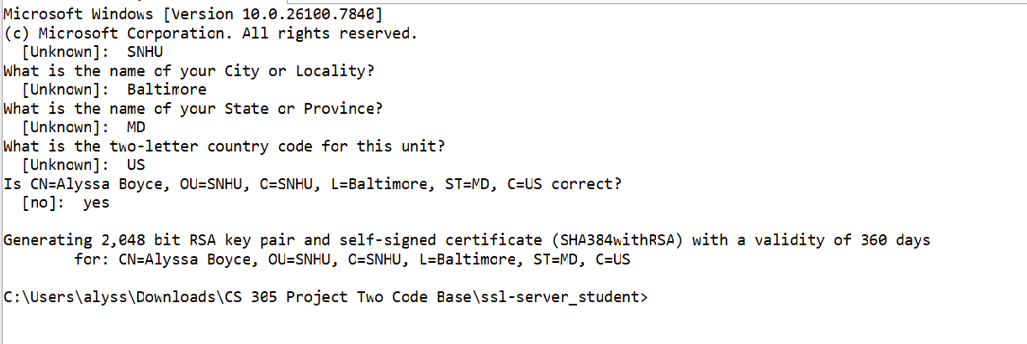
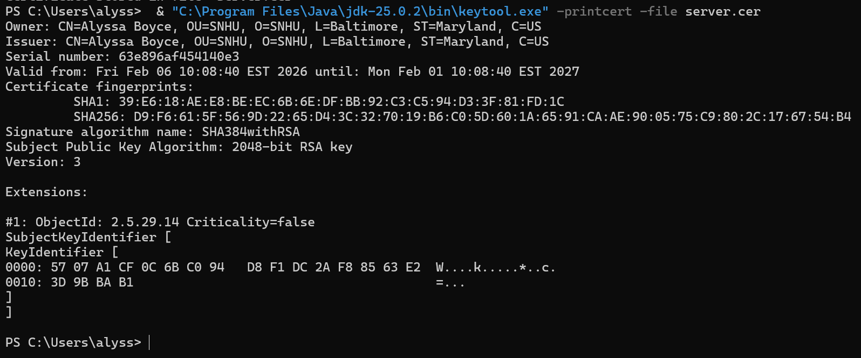

Deploy Cipher
Insert a screenshot below of the checksum verification.

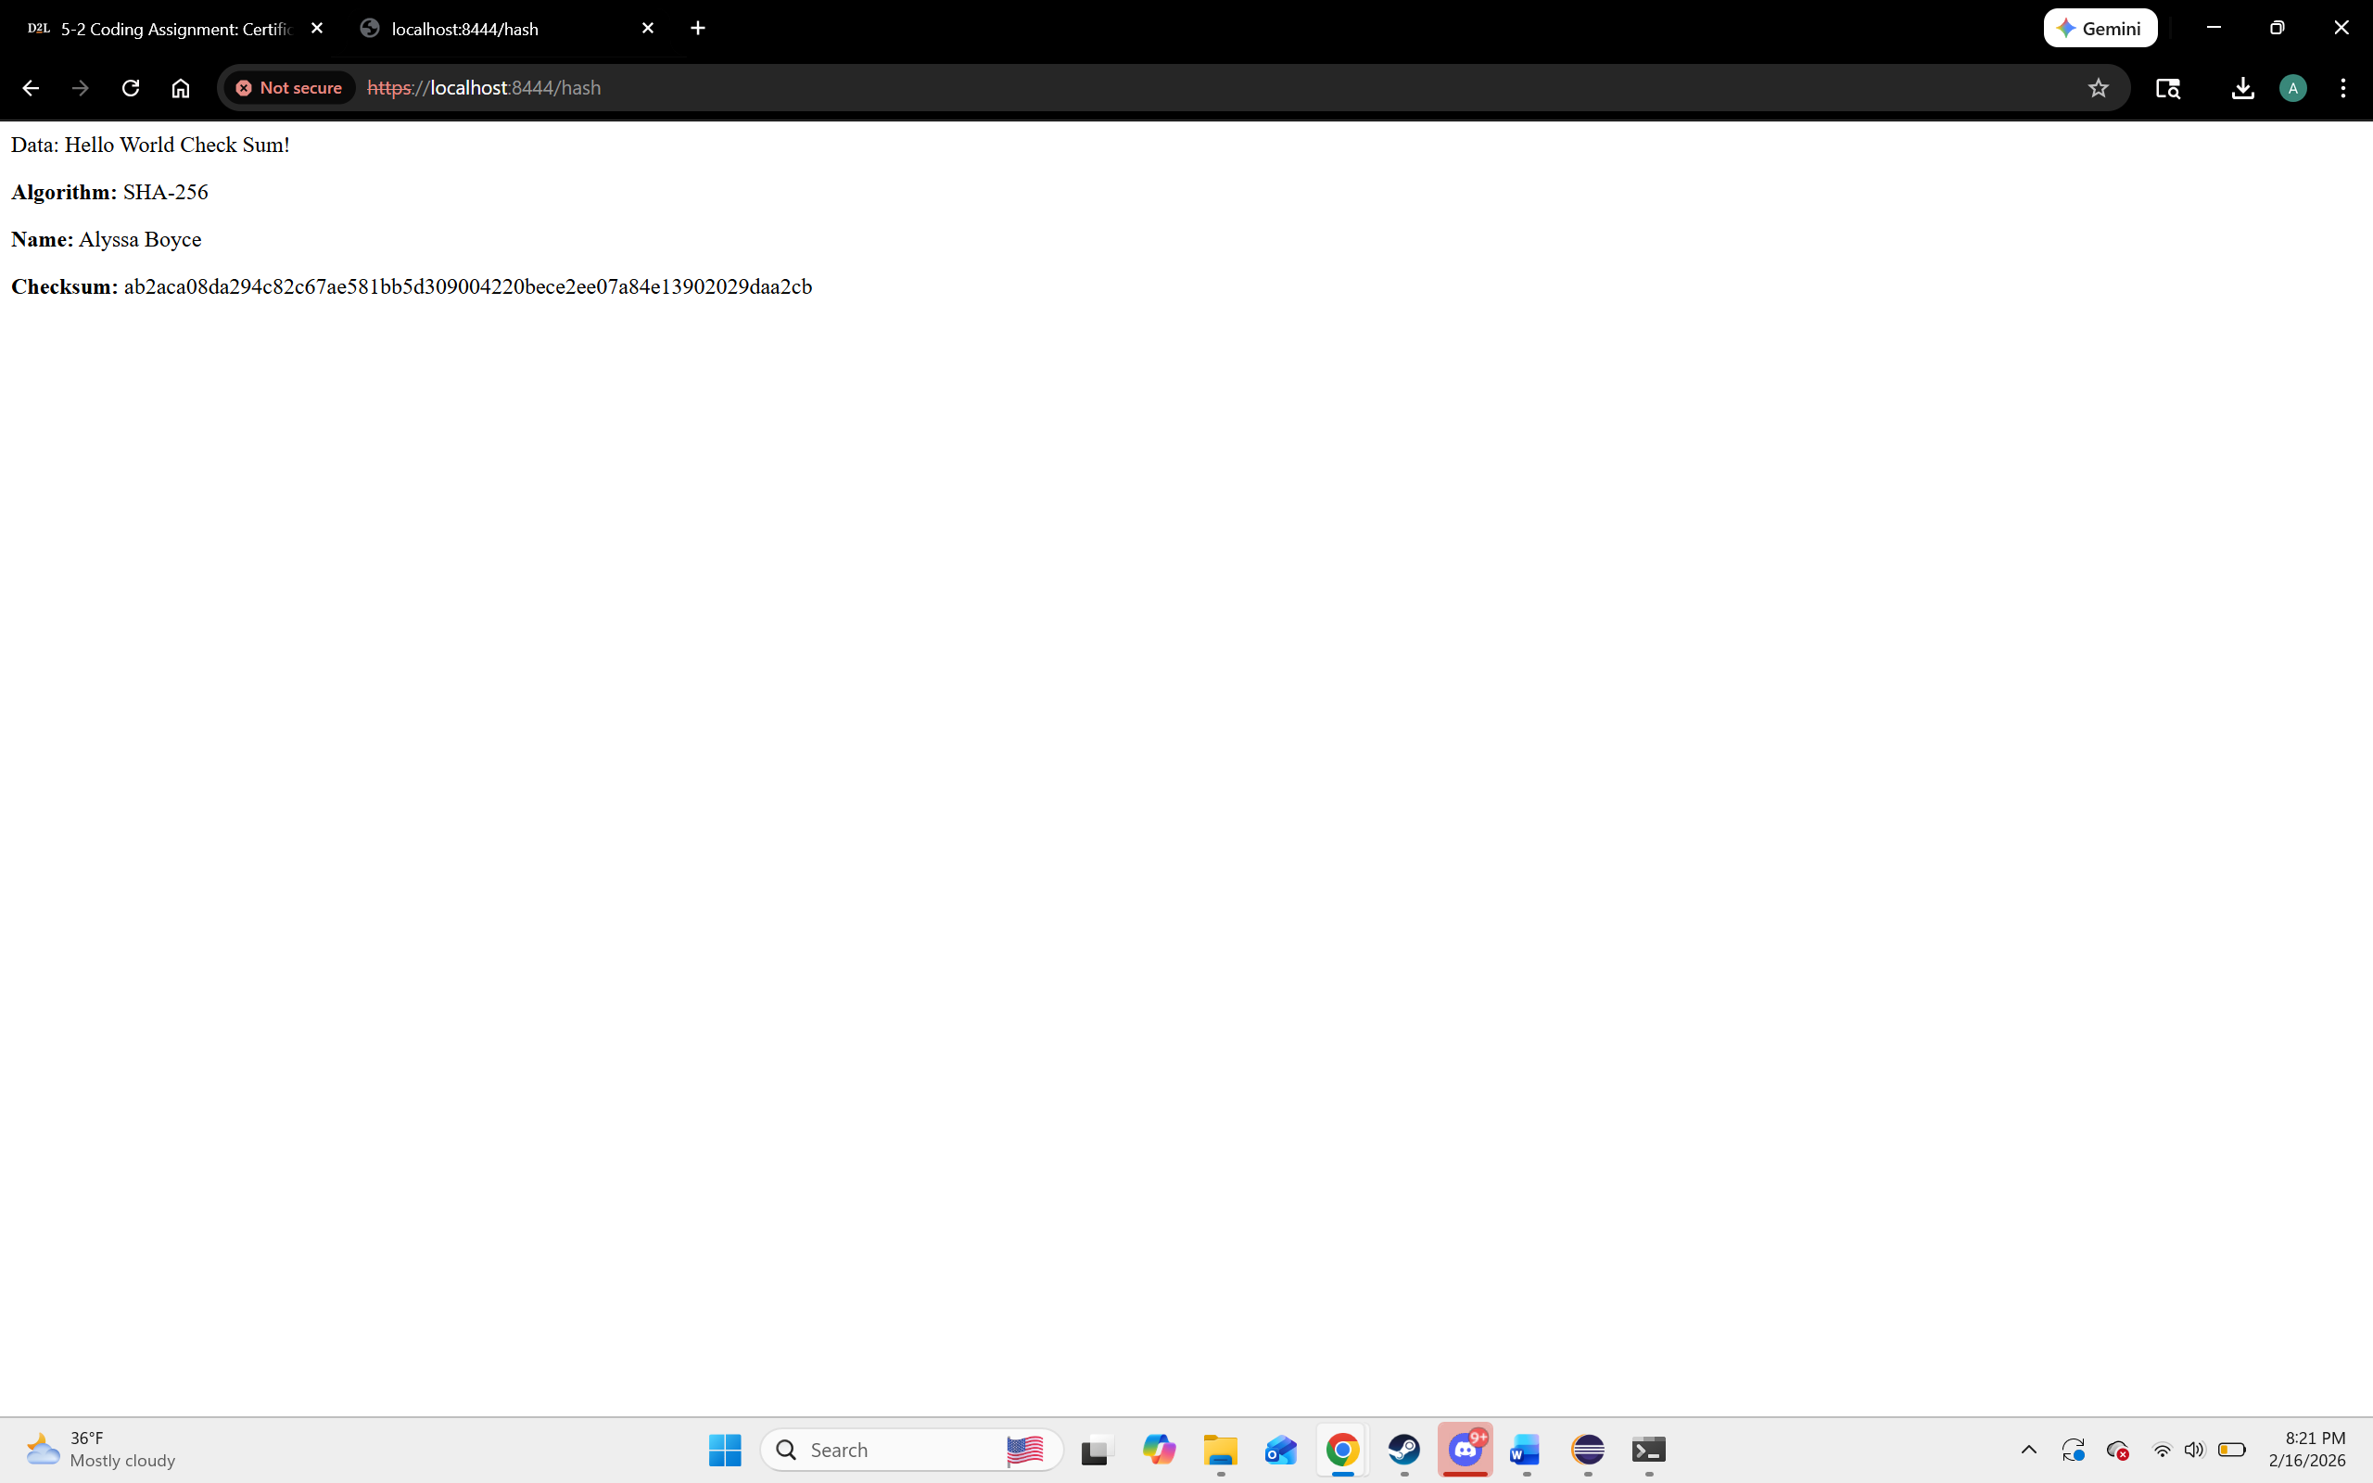
I changed the port to 8444 rather than 8443 due to running it first without the name and unique string then the port was already in use. So I switched the port slightly.

Secure Communications
Insert a screenshot below of the web browser that shows a secure webpage.

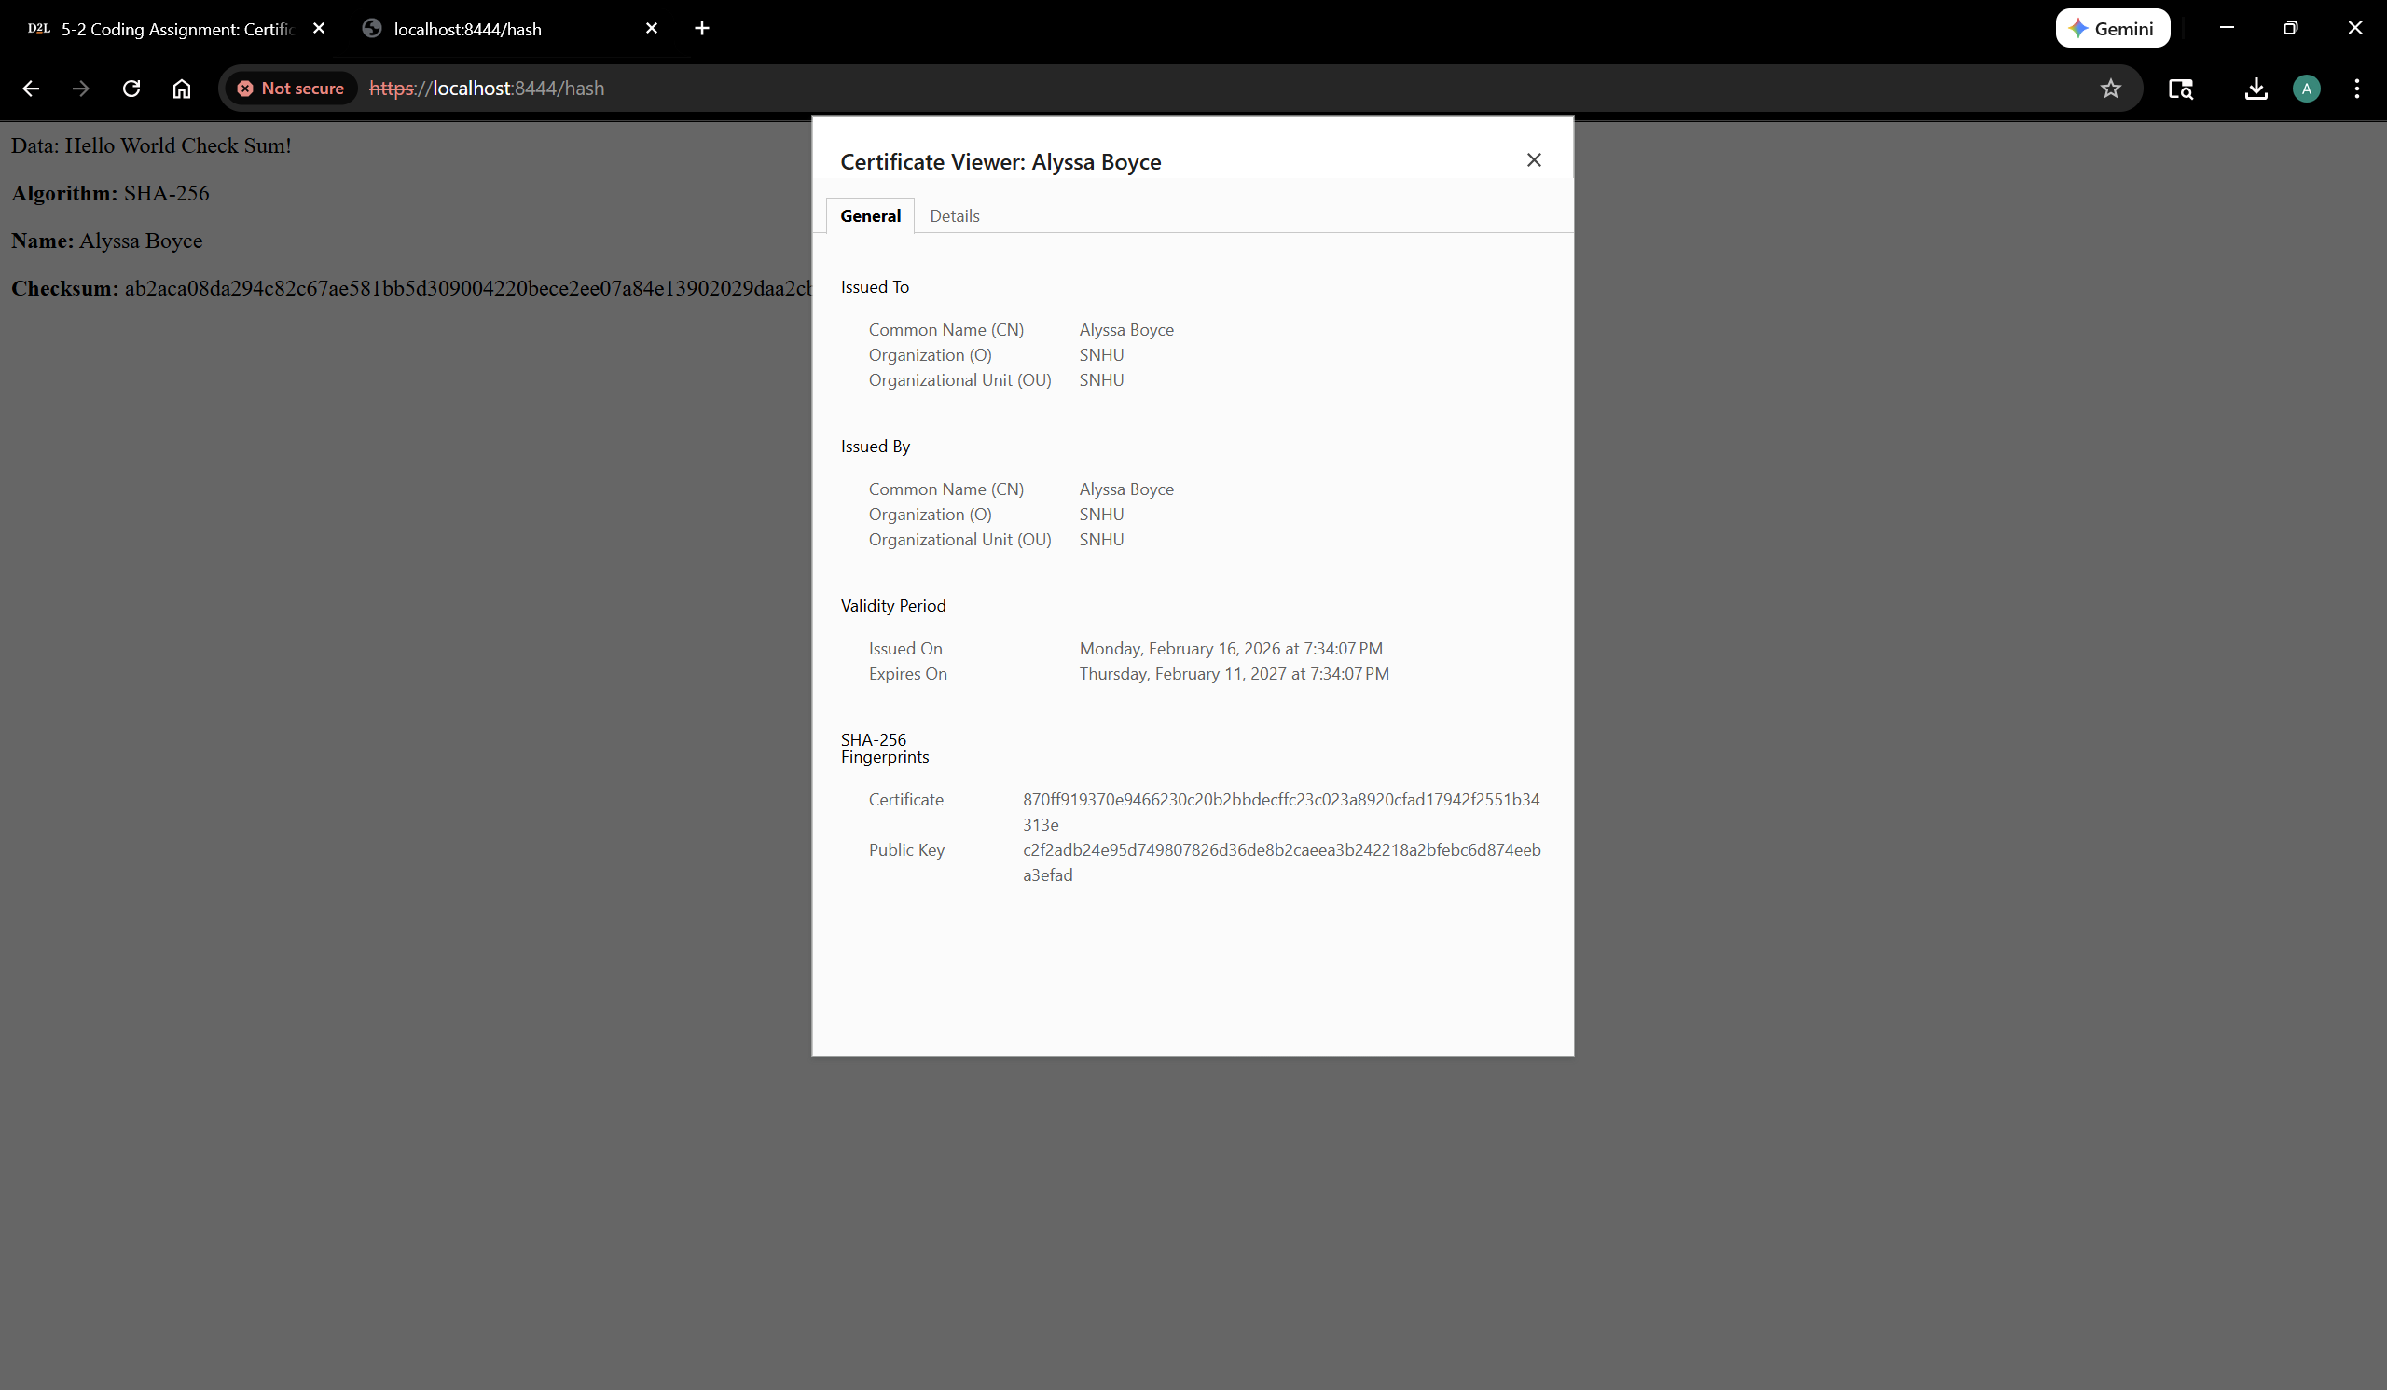

Secondary Testing
Insert screenshots below of the refactored code executed without errors and the dependency-check report.

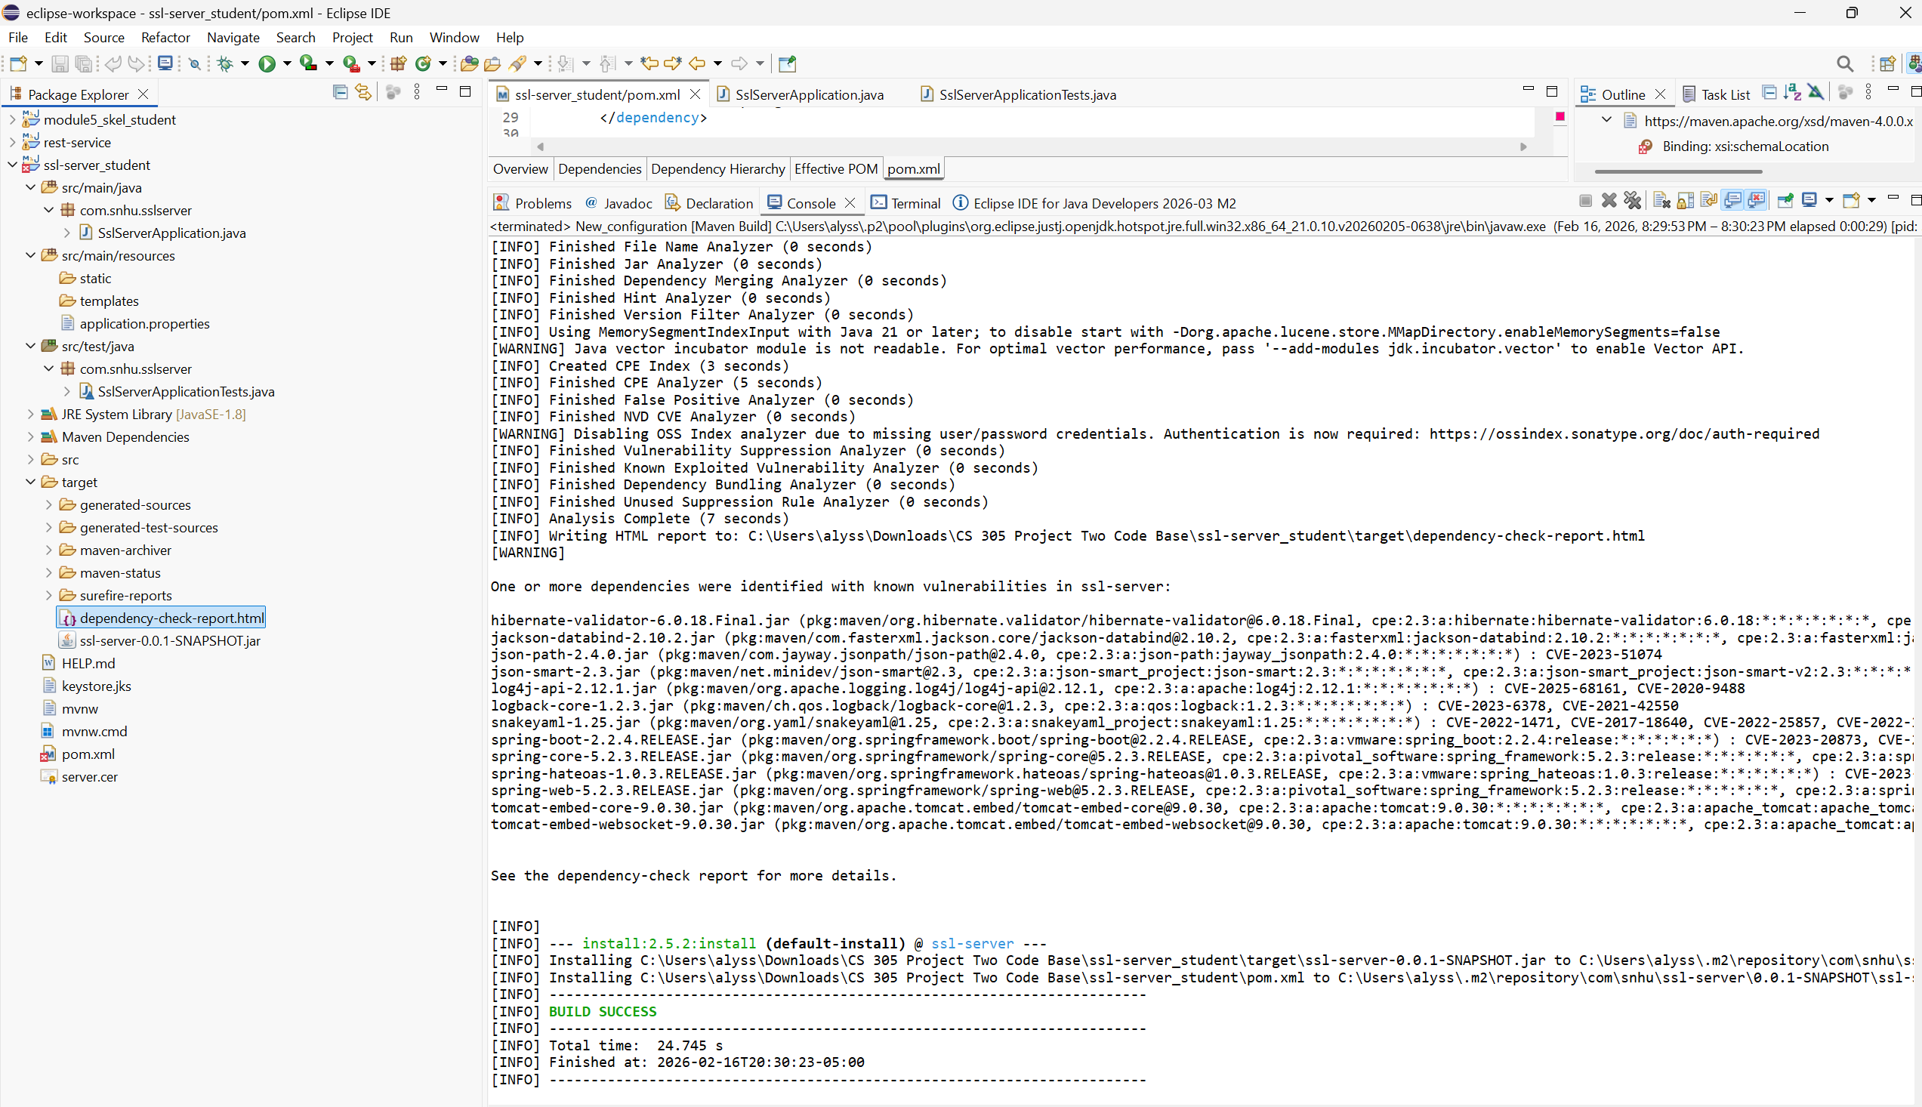
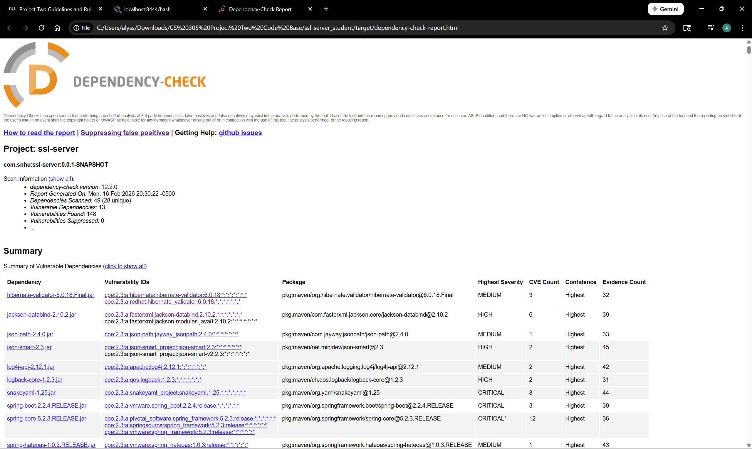

Functional Testing
Insert a screenshot below of the refactored code executed without errors.

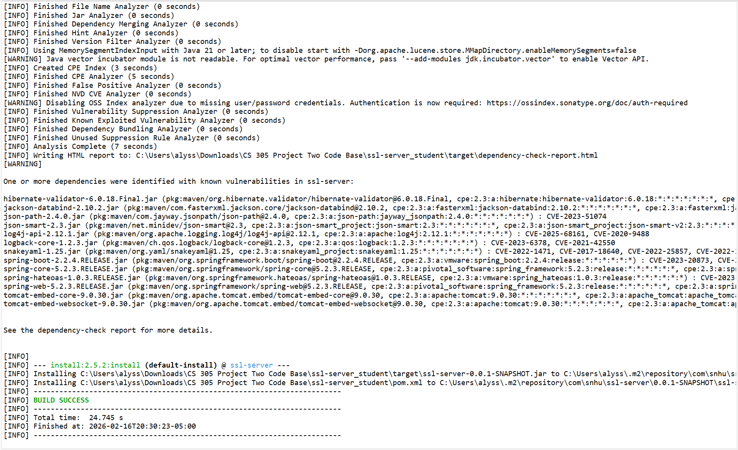

Summary

Throughout refactoring the code, REST endpoints were implemented to create a web-accessible route to ensure that the checksum was functional and able to be accessed. A cryptographic configuration was added to ensure that the hash function was designed for the checksum generation. This improves data integrity and detects tampering as well as creating a layer of security. Encoding the hash output to ensure that bytes were changed to a hex string so that the correct output was generated. As well as changing the information in application properties to ensure that certificate authentication was working properly as well as establishing a secure local server for testing purposes.

Industry Standard Best Practices

To ensure that the security of the software application is maintained it is important to identify potential threats and ensure that those potential threats are not false positives. Throughout this application data encryption was implemented with SHA-256. But to maintain the security of the program it is important to run regular tests to ensure that new threats do not arise and if they are new security measures can be put into place to ensure that they are eliminated. To add to standard industry practices the use of a suppressions file could be used to weed out the false positives to ensure that the security team is not pouring their time and energy into protecting against false positives and vulnerabilities are streamlined. Overall, the value to standard practice when it comes to security is not only important to the client using the platform but also the company, when companies are protected against cyber attacks it not only protects the customer but also protects the company against legal action that customers could partake in if their data was leaked, as well as overall company reputation. When data leaks occur it is usually spoken of, if not in the news by word of mouth and customers will be driven away from companies with unsecure platforms. Companies are able to stay safe in other ways too, as keeping a secure platform will cut down on ransom attacks where companies would have to pay out large sums of money to obtain their platform again. So with the use of industry standard best practices it not only keeps the customers information safe it also protects the public image of the company and their pockets.

Cited Sources:

Oracle. (n.d.-a). Keytool - key and certificate management tool. keytool-Key and Certificate Management Tool. https://docs.oracle.com/javase/6/docs/technotes/tools/windows/keytool.html

Schneider, J. (2025a, November 17). The history of Cryptography. IBM. https://www.ibm.com/think/topics/cryptography-history

SSL Shopper. (n.d.). How to Create a Self Signed Certificate using Java Keytool. How to create a self signed certificate using Java Keytool. https://www.sslshopper.com/article-how-to-create-a-self-signed-certificate-using-java-keytool.html

